**Bhavesh Patel 39**

**Piyush Saravagi 42**

**Suyash Thakare 54**

**Class Diagram**

The class diagram is the main building block of object-oriented modelling. It is used both for general conceptual modelling of the systematics of the application, and for detailed modelling translating the models into programming code. Class diagrams can also be used for data modeling. The classes in a class diagram represent both the main elements, interactions in the application, and the classes to be programmed.

**Use Case Diagram**

To model a system the most important aspect is to capture the dynamic behavior. To clarify a bit in details, dynamic behavior means the behavior of the system when it is running /operating.

So only static behavior is not sufficient to model a system rather dynamic behavior is more important than static behavior. In UML there are five diagrams available to model dynamic nature and use case diagram is one of them. Now as we have to discuss that the use case diagram is dynamic in nature there should be some internal or external factors for making the interaction.

**Sequence Diagram**

A Sequence diagram is an interaction diagram that shows how processes operate with one another and in what order. It is a construct of a Message Sequence Chart. A sequence diagram shows object interactions arranged in time sequence. It depicts the objects and classes involved in the scenario and the sequence of messages exchanged between the objects needed to carry out the functionality of the scenario. Sequence diagrams are typically associated with use case realizations in the Logical View of the system under development. Sequence diagrams are sometimes called event diagrams or event scenarios.

**Class Diagram**

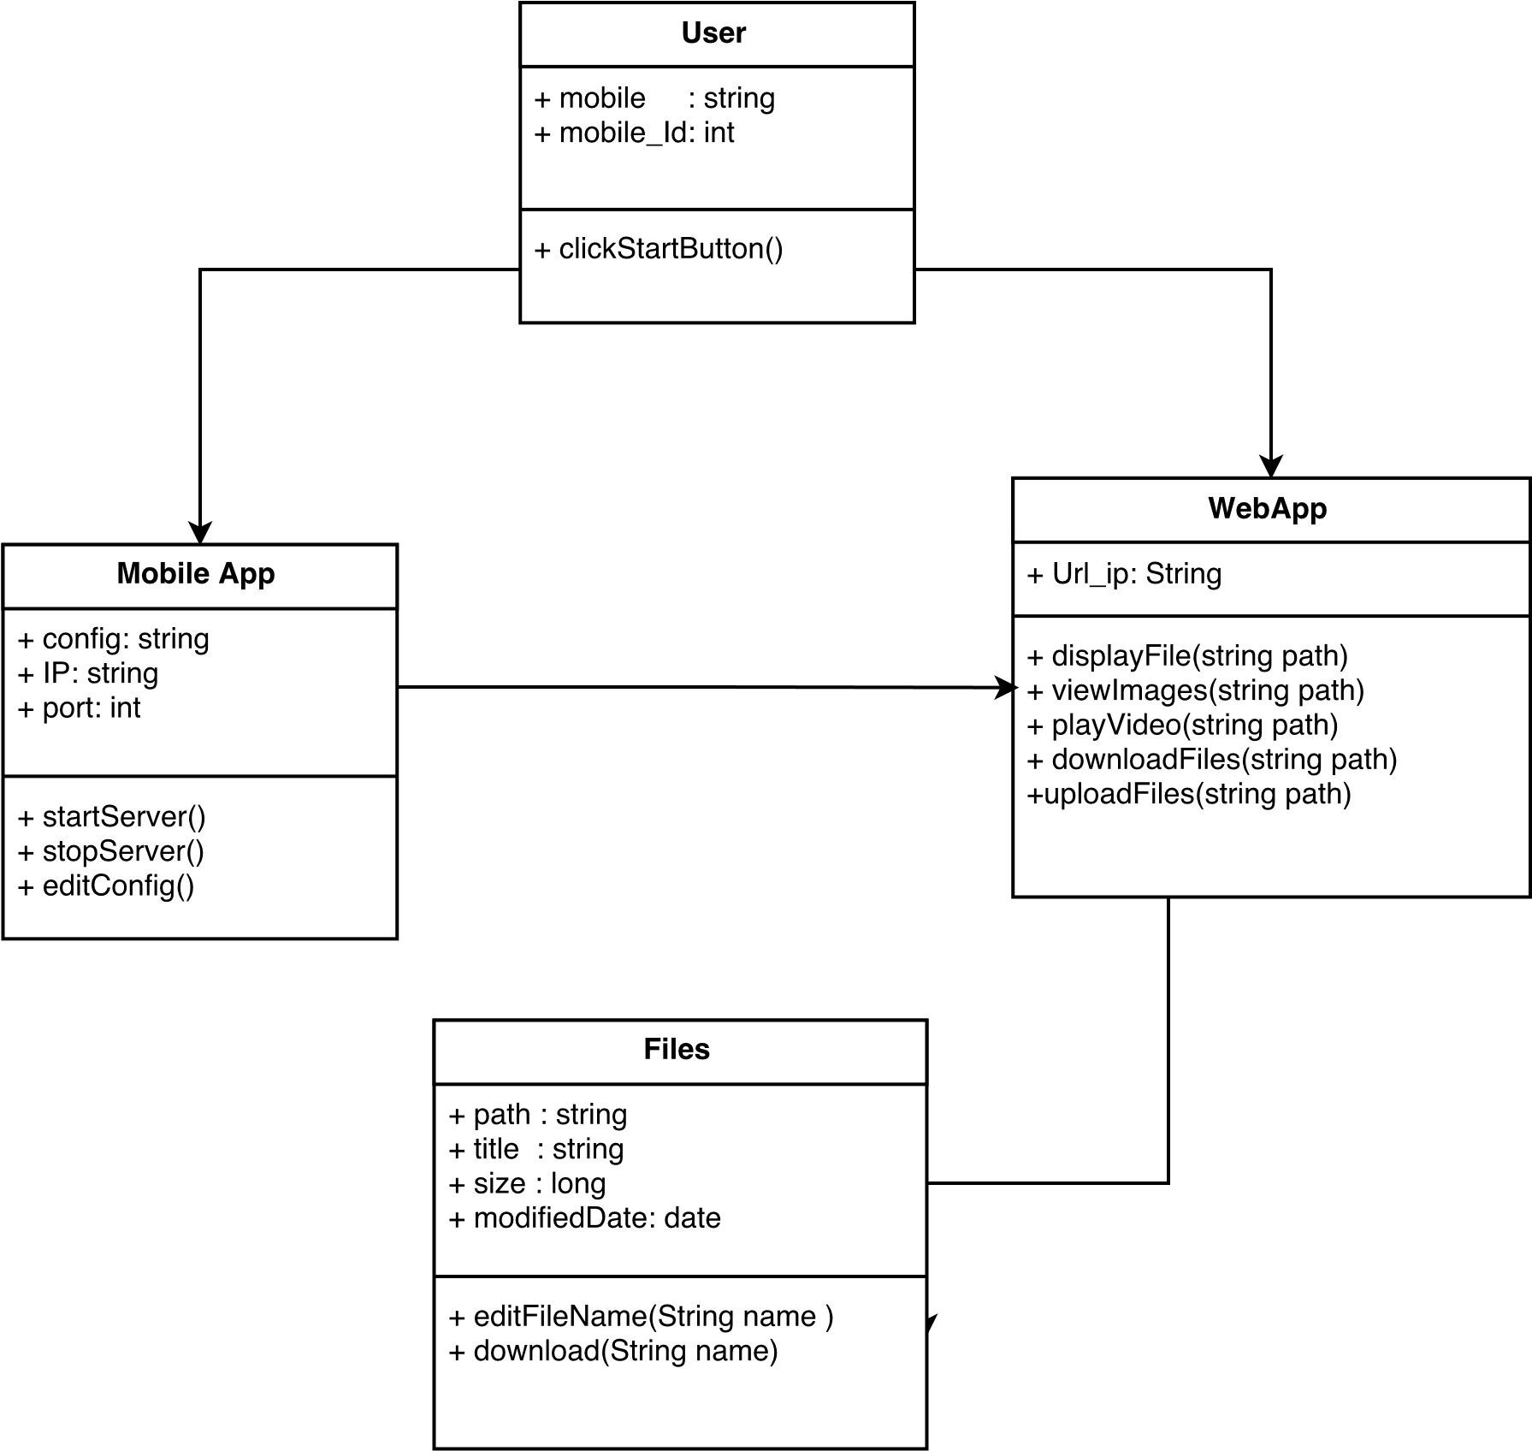

**UseCase**

**Sequence Diagram**

